Pages 90 – 99 ***Java Programming A Comprehensive Introduction***

**Section 1: Define / Answer**

Name 2 differences between a **for** loop and a **while loop**-

Definite Loop- Looping stops after limited number of times as stated in conditional statements.

Indefinite Loop- Indefinite looping keeps looping infinitely but it has stops at some point.

Infinite Loop- Unlike indefinite looping, Infinite looping keeps looping and it never stops.

What is the basic difference between a **do-while** loop and [**or/while]** loops? Do while loops runs the block of code before it check the condition, but while loops first check the condition, and its condition has to be passed before run the code.

How do **break** statements work in relation to **for, while,** and **do-while** loops? After the conditional code run, break statements prevent running the code beyond it and after first run looping starts from the beginning.

Describe how an infinite **for** loop operates. When the condition within for loop doesn’t turns false, the code block within for loop keeps running infinitely many times.

**Programming Assignments**

**1st Task: Pg. 115 #15** Java Programming *A Comprehensive Guide*

There are 6 different programs + output required for this assignment.

Please Have 6 Different snipping photos with programs and outputs.

Hint** The programs should not be very long for each answer.

The Class **ContDemo** in Chapter 3 shows one way to use a **for** loop to **print the even numbers 0 to 100.** Write programs that print the same output as that program, but do it in the following ways:

1. Using a **for** loop that increments the loop control variable by 2 each iteration
2. Using a **for** loop whose loop control variable goes from 0 to 50.
3. Using a **for** loop whose loop control variable goes from 100 down to 0.
4. Using an infinite **for** loop with no conditional expression and exiting the loop with a **break** statement.
5. Using a **while** loop.
6. Using a **do-while** loop.

There should be 6 different Snipping photos. One photo for each program A – F.

A.

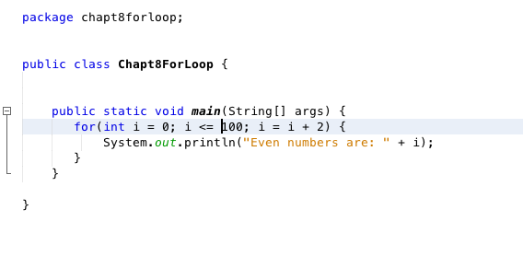

B.

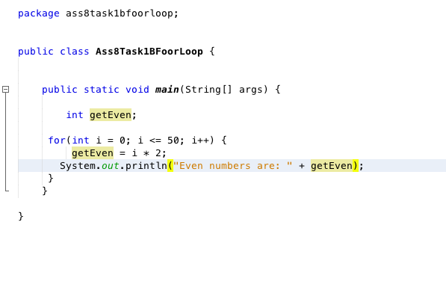

C.

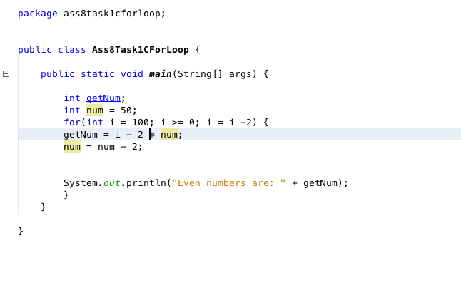

D.

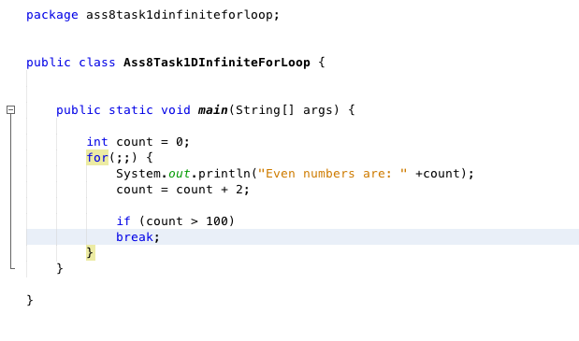

E.

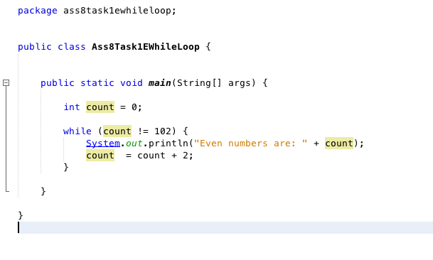

F.

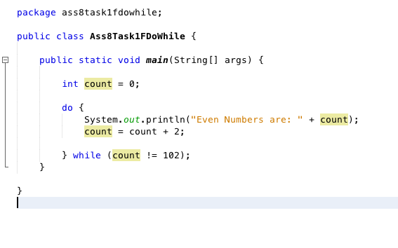

Output for A, B, C, D, E, F

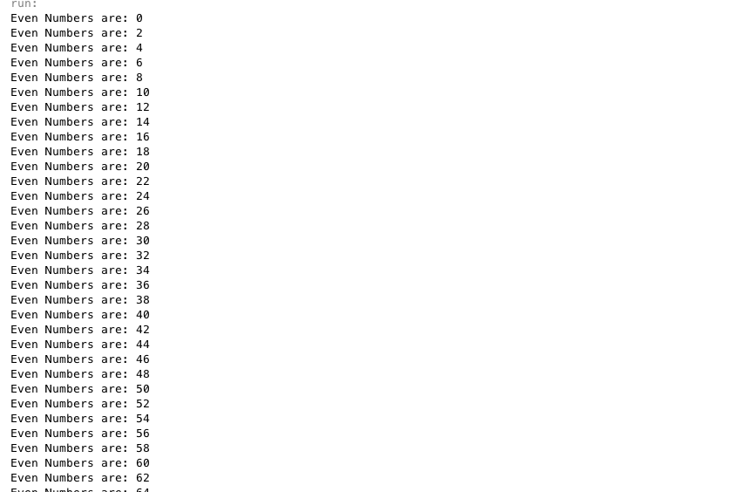

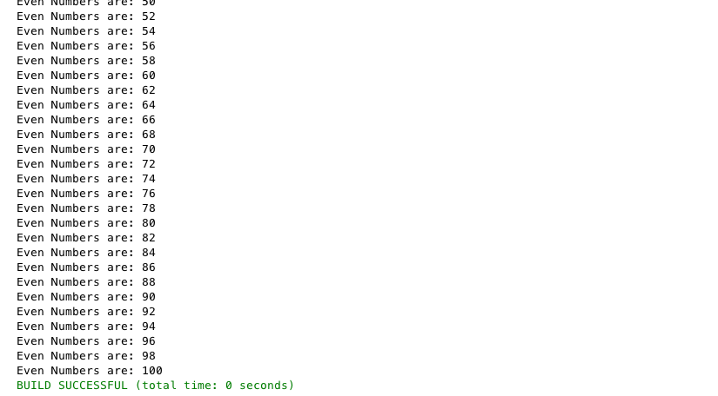

**2nd Task-** Change Calculator

Write a program that directs a cashier how to give change. The program has two inputs: The amount due and the amount received from the customer. Display the dollars, quarters, dimes, nickels, and pennies that the customer should receive.

